Software Engineering Group 11

SE_11_PP_02

Project Plan - Overview

Author: Tom Raikes (tor10), Aled Davies (add20), Aloysius Fernandes (alf33)

Configuration Ref: SE_11_PP_02

Date: 2014-10-30

Version: 1.3

Status: Release

Department of Computer Science

Aberystwyth University

Aberystwyth

Ceredigion

SY23 3DB

Copyright © Aberystwyth University 2014

Table of Contents

1. Introduction 3

1.1. Purpose of Document 3

1.2. Scope 3

1.3. Objectives 3

2. System Architecture 4

2.1. System Architecture Diagram 4

2.2. Client 5

2.2.1. Field Entry 5

2.2.2. Field Recall 5

2.2.3. Upload Screen 5

2.2.4. Settings 5

2.2.5. Model 5

2.2.6. Local Database 6

2.3. Server 6

2.3.1. Request Handler 6

2.3.2. Model 6

2.3.3. Update Handler 7

2.4. Web 7

2.4.1. Browse 7

2.4.2. Record View 7

2.5. Database 7

3. REFERENCES 8

4. DOCUMENT HISTORY 8

# Introduction

## Purpose of Document

The purpose of this document is to be an individual part of the final project plan, this is being kept as a separate document to allow for version control and drafting of this particular section.

## Scope

This document aims to be an overview of the architecture of the final system that the group is building.

## Objectives

This document covers:

* The Client (i.e. Android application) structure.
* The Server Structure.
* The Database Structure
* The Web Page Structure

# System Architecture

## System Architecture Diagram

## 

## Client

Our Android application will be designed for Android version 4.0+, as we feel older versions are losing their market share [1]. Android version 4.0+ has 87.9% market share, made up of Ice Cream Sandwich, KitKat and Jellybean. The client describes the Android app and all its features.

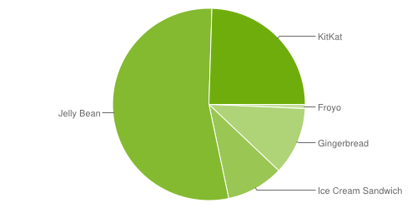

### Field Entry

This will be the primary screen for inputting data into the local database stored on the Android device. This can be accessed from the initial screen of the application.

### Field Recall

This allows the user to view previous entries, accessing the same ‘fields’ model that the field entry screen has access to. This is also available from the initial screen of the application.

### Upload Screen

This screen directly accesses the ‘fields’ model. Any field items recording by the Field entry screen (2.2.1) will be added to a queue ready to be uploaded to the external database. This screen should also have the feature to browse records and choose which to upload to the server and potentially being able to filter by date.

### Settings

This screen interfaces with the local configuration file to allow users to store preferences locally on the device and have them remembered (i.e. Prefer Wi-Fi over Mobile network).

### Model

This describes local content stored on the device, whether that’s the configuration file or the entry fields ready to be uploaded to the database.

#### Model – Fields

These are the fields ready to be uploaded to the database, they will be stored locally until an internet connection can be accessed to upload records.

#### Model – Config

This is the locally stored user preferences file, this will be accessible locally and potentially via the database (client may wish to switch devices).

### Local Database

This is not ‘strictly’ a database but a collection of records that will be stored ready to be sent to the server. Records can only be sent when an internet connection is achieved.

## Server

This will utilise the universities LAMP server, this will handle communication between the application and database. This server will not physically contain the database as this will risk a security issue.

### Request Handler

The request handler deals with communication between the client and server, it’s primary function is to send data back and forth between the client and server. Included in its functionality is the ability to check incoming data for errors and to confirm to the client that data had been received and added to the database.

### Model

Transforms raw data from client into database readable information. This information is then passed to the update handler.

#### Model – Species

Sorts data related to species.

#### Model – Recordings

Sorts data related to recordings.

#### Model – Reserves

Sorts location data and reserve data.

#### Model – Species Occurrence

Sorts data related to species occurrence.

### Update Handler

Takes information from the model (2.3.2) and creates a SQL statement using the received information ready to be sent to the database in a database readable format. Sends data to the request handler to confirm that information has been added to the database.

## Web

The web application makes use of PHP to retrieve data from the database and display that as information on the web app. The PHP will also send data to the server and we will use JQuery to Login. It will also make use of HTML and CSS to make the website look professional and user friendly. We will design our web application to support modern web browsers, particularly those that hold a larger market share. The image below is taken from W3 schools and is their report on the market share of the most popular browsers [2]. We can interpret from the following information that our priorities will be Google Chrome and Firefox.

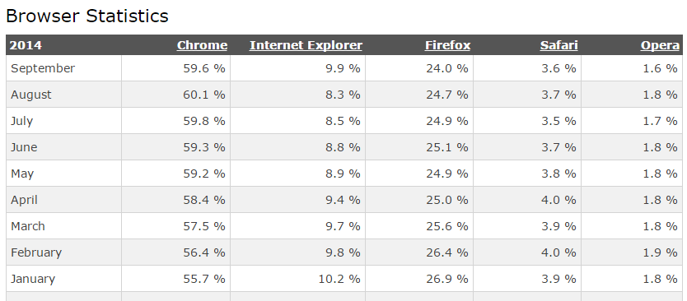

### Browse

This module of the web application will allow the user to browse records which have been retrieved from the database, the user will option to search/filter the records to make the browsing more user friendly.

### Record View

This module is a more detailed view of a particular species.

## Database

This will be where processed information will be stored, it will either be MySQL or PostgreSQL. It will consist of several tables each containing data relevant to the table.

# REFERENCES

[1] <https://developer.Android.com/about/dashboards/index.html> (21/10/14)

[2] <http://www.w3schools.com/browsers/browsers_stats.asp> (30/10/14)

# DOCUMENT HISTORY

|  |  |  |  |  |
| --- | --- | --- | --- | --- |
| Version | CCF No. | Date | Changes made to document | Changed by |
| 1.0 | N/A | 20/10/14 | Document Created and Structured | Add20 |
| 1.1 | N/A | 21/10/14 | Document fleshed out and into proper English (out of note form). | Add20 |
| 1.2 | N/A | 28/10/14 | Restructured Into new Template Supplied by als48. Document put into ‘In Review’ Status | Tcg2 |
| 1.3 | #6 & #7 | 30/10/14 | Added more robust description of browser choices under web and fixed system diagram overlap | Add20 |